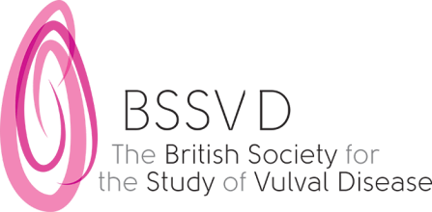

BSSVD Meeting Bursary

The British Society for the Study of Vulval Disease has established a bursary to help towards the meeting costs for a trainee who wishes to present their work at a BSSVD meeting. The bursary is worth £300. BSSVD meetings take place annually.

Please submit your abstract in the normal way for the meeting. The meeting organiser will judge the abstracts and the top rated abstract (of those who have submitted an application for the grant) will receive the grant.

- Applicants must be members of the Society
- Application forms can be downloaded from the Society’s website: www.bssvd.org The grant will be payable within 4 weeks of the BSSVD meeting

